**Terms of reference**

**Digital Seed Tracking-Tracing System (STTS) Deployment and User Training**

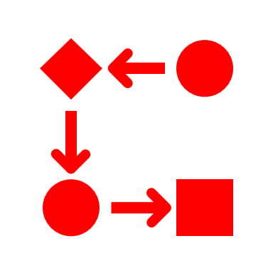

ISSD Sahel

**Teams of Facilitators**

Geoffrey Otim[1], Isaac Mbabazi[2], Priscilla Amokol[3]

**Table of Contents**

1. Introduction 1

1.1 Principals of adaptation Concept of Tracking and tracing 1

1.2 Objectives of the system deployment and user training mission 2

2.0 Overview of the system adaptation undertaken 2

2.1 Adaptations overview 2

2.2 The mission expectations and deliverables 3

2.3 Overview of the proposed program 3

3.0 Description of sessions and stakeholders participation 5

3.1 Pre-training sessions 5

3.2 System configurations sessions 5

3.3 Main training sessions 5

# **Introduction**

Integrated Seed and Sector Development (ISSD) Uganda in partnership with Eight Tech Consult Ltd, a local ICT firm in Uganda is undertaking adaptation process of the digital seed tracking and tracing system (STTS) for the ISSD Sahel. The digital Seed Tracking and Tracing System (STTS) provides real-time information on the movement of seed along the value chain to ensure strategic decisions on quality-related issues that can enable its technological benefits to be realized by all value chain actors more especially regulators and farmers. ISSD Sahel identified STTS as one of the key innovation they want to introduce in the Sahel seed system following their learning visit to Uganda Seed Sector in early 2021. The STTS adaptation process was done following the ecosystem assessment conducted by ISSD Uganda and Eight Tech team mid 2023 in Niger and Mali respectively. The ecosystem assessment revealed a close similarity between the two countries Seed system regulatory systems and environment. This terms of reference provides details on the next step of the digital STTS adaptation involving system deployment and user training for the Sahel seed sector stakeholders.

# **Principals of adaptation Concept of Tracking and tracing**

Tracking (following the seed production sequence from the breeder’s nursery fields through to certified/ quality declared (QDS) seed, and even to sales) and tracing (following a seed sale backward sequence from certified seed back to Breeders’ seed production lots and fields) are important aspects of quality assurance in the seed value chain (Figure 1).

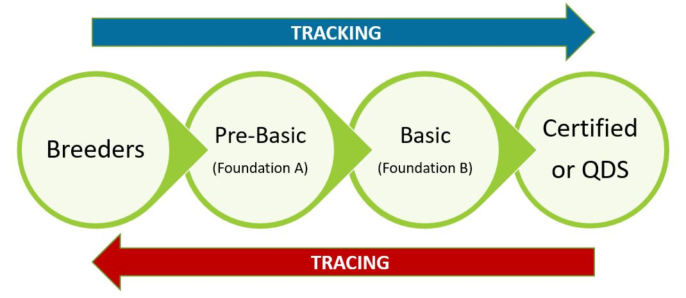

**Figure 1: Concept of Tracking and tracing system used in adaptation process**

This involves recording the seed source, seed production of each seed field, seed lots at each seed producers, and seed packs with the use of unique seed field/lot identifiers. Tracking is particularly aimed at identity preservation and quality assurance, while tracing is aimed at solving problems faced by product non-conformance in customer experience or at any point along the seed production value chain.

Tracing is also required for product recall to the point of non-conformance with quality. Both tracking and tracing should be inherent in the country’s seed laws to complement the sector in the essential aspect of protecting seed users from counterfeit seeds. STTS enforces access to affordable quality seed which is the foundation of increasing agricultural production and productivity which are needed for food and nutrition security and income for farmers. It also provide opportunity for pre-booking for early generation seed to improve seed sector planning for production of demanded seed.

# **Objectives of the system deployment and user training mission**

This mission is designed to allow deployment of the adapted STTS for the Sahel region and provide training of the users.

Specifically the mission targets to;

1. Present the adapted STTS to the stakeholders
2. Input relevant seed sector data in the system to allow better visualization
3. Obtain stakeholders observation and comments on the adapted system
4. Configure the system based on and observations by the key stakeholders
5. Train key stakeholders on system operations and use
6. Discuss system migration process and handover

# **Overview of the system adaptation undertaken**

The STTS adaption was a knowledge co-creation based the seed sector workflows identified by the respective countries of the Sahel during the ecosystem assessment conducted in each country. The adaptation targeted these workflows which were directed by the country seed sector regulations and practice.

The portal was then designed and reviewed virtually by the stakeholders. Although these provided insight into the system, proper understanding and review of the system was a challenge due to connectivity problems during the meetings. This has limited the ability to test the system and obtain relevant feedback as part of the agile system development we follow.

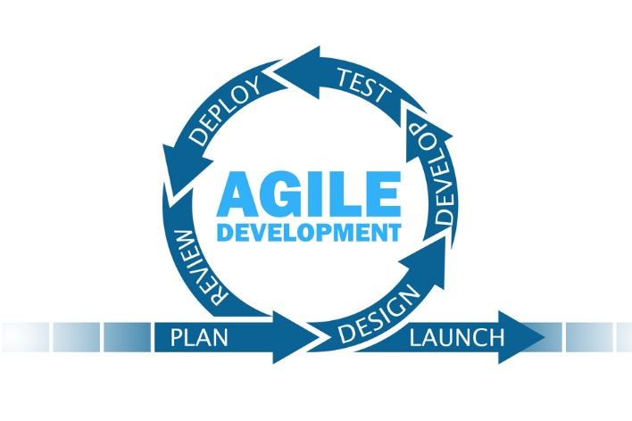

# **Adaptations overview**

* Workflows
* Administrator module
* Seed producers/grower module
* Quality assurance module (field and Laboratory)
* Seed users module
* Language choice compatibility French/English

# **The mission expectations and deliverables**

This phase of the STTS adaptation mission expect to achieve the following expectations/deliverables;

* Data entry of all the crops and their varieties in the system
* Data entry of all the crop inspections
* Review and the system modules, process flows and gather any new requirements
* Discussion of the system hosting and access controls
* Training of trainers on how to use the seed tracking and tracing system
* Training of crop inspectors on crop inspection
* System upgrade and update session
* Emerging requirements documentation and validation

# **Overview of the proposed program**

|  |  |  |
| --- | --- | --- |
| DAY/DATE | DETAILS/SUB-THEMES | Facilitators |
| **PRE-TRAINING SESSIONS FOR ONLY SELECTED STAKEHOLDERS** | | |
| Pre-Training  DAY 1  30th Oct 2023 | * Understanding the system modules, the process flows and system user roles * How to access the system? * How to login to the system * System configuration * Adding crops and varieties * Adding field inspection schedules * User management | ISSD Uganda |
|  | Lunch Break. |  |
|  | * Data management * The registration module * Applications * Submission of planting returns * Review of what has been covered * Q&A | ISSD Uganda |
| Pre-Training  DAY 2  31st Oct 2023 | * Review of what was covered in day 2 * Managing planting returns * Field inspection * Seed stock update? * Seed stock examination * Seed sample analysis * Seed Lab testing * Lot number generation | ISSD Uganda |
|  | Lunch Break. |  |
|  | * Seed labels * Market access module * Seed Tracking and Tracing * QRCode * Review of all the observations and suggestions * Closure | ISSD Uganda |
| DAY 3  1st Nov 2023 | **System configurations**  Addressing and configuration of the suggestions and comments identified by stakeholders during the pre-training session. | ISSD Uganda |
| **MAIN TRAINING SESSIONS FOR ALL STAKEHOLDERS** | | |
| DAY 1  2nd Nov 2023 | Opening sessions   * Registrations * Prayer * Self-introduction * Welcome remarks * Workshop objectives * Official opening of the training | ISSD Uganda |
|  | * Accessing the STTS * Creating user accounts. * Login to the STTS * How to apply as a Seed Company and Seed Merchant. * Tracking your application status. * Changing and editing your application. * Submitting your planting returns. | ISSD Uganda |
|  | Lunch Break. |  |
|  | * How to submit seed stock examination requests? * Tracking your stock examination request. * How to submit a seed sample request for the seed Lab testing? | ISSD Uganda |
| DAY 2  3rd Nov 2023 | * Review of what was covered on training day 1 * Seed Lab testing * Seed Lot Number * How to access your Lab test results? * Seed Label application * Tracking your Label application * Modifying the application status | ISSD Uganda |
|  | Lunch Break. |  |
|  | * Assign Label request to LABOSEM * How to issue Labels by LABOSEM * Review of what has been covered * Q&A * Closure of day 4 | ISSD Uganda |
|  |  |  |
| DAY 3  4th Nov 2023 | * Review of what was covers on training day 2. * How to apply for seed Labels * Assign Label request to LABOSEM * How to issue Labels by LABOSEM * Seed stock (Stock increase and deductions) * Marketable seed and None Marketable seed. - Market Place | ISSD Uganda |
|  | Lunch Break |  |
|  | * Seed Orders * Pre-orders * Seed Tracking and Tracing * My Profile * Q & A * Closing Remarks. | ISSD Uganda |
| 5th Nov 2023 | System clean up and further configuration from the Main training observations | ISSD Uganda |
|  |  |  |
| 6th Nov 2023 | * Training of key IFDC team on system management, hosting and trouble shooting. * Discussion of system hosting and exit strategy of the adaptation team. | ISSD Uganda |
| 7th Nov 2023 | Experts depart Sahel for Uganda | ISSD Uganda |

# **Description of sessions and stakeholders participation**

The deployment and user training mission will involve pre-training, system configuration and main stakeholders training sessions as described below.

# **Pre-training sessions**

This session will involve selected stakeholders, usually a good mix of technical teams with good understanding of the regulatory environment in the seed sector of the two countries of system deployment (4-8persons). They will make critical observations on workflows and provide suggestions for systems adjustments ahead of the main training sessions. These team also provide relevant data and input in the system for better visualization during the main training sessions.

# **System configurations sessions**

This session involves only technical experts/developers of the systems to incorporate the observations and clean up the data input during the pre-training session. A representative of the stakeholders may be helpful to support any questions arising from the software engineer.

# **Main training sessions**

This is the main training session involving all the stakeholders.

1. Seed system and policy expert
2. ICT Developer and trainer
3. Software Engineer